Introduction To Woodwork
School of Woodwork

Table of Contents
Design 3
Some Design Formulas that Sometimes Help 4
The Golden Rule 4
The Fibonacci series 4
Standard Dimensions 5
Table Dimensions 5
Chair Dimensions For Average – Sized Adults 5
Standard Dimensions for Bedroom Furniture 5
Maximum No Sag Spans for Various Shelf Materials 6
Standard Dimensions of Bookcases and Shelves 6
Construction Drawings 7
Front Elevation 7
Plan Elevation 7
Cut List 8
Final Cut List 8
Lumber Yard Cut List 8
Wood Selection 9
Wood and It’s Properties 9
How Wood is Cut: Quarter Sawn, Face Sawn, Rift Sawn, Veneers 9
Plain Sawn Lumber 9
Quarter Sawn Lumber 9
Rift Sawn Lumber 10
How to Calculate How Much Wood You Will Need 10
What to Look For When Buying Wood 10
Places to Buy Wood 11
Mortise and Tenon Joints 12
Finishing 13
Questions To Ask About Finishes 13
Available Finishes 13
Waxes 13
True Oils 14
Varnishes 14
Oil and Varnish Blends 15
Shellac 15
Lacquers 15

The Design Process
Often new woodworkers are focused on building their technical skills and building pieces that meets purely functional requirements. While important for development this is not the only aspect that can be practices and refined over time. One of the elements often left behind in the early work is design, but design can be something that results in a more unique piece that is reflective of the maker.

Design
The process for designing a unique piece generally follows these steps:
- Develop a Concept
  - Think first – find the idea that delights you from either the human world or the natural world. Sketch – doodle – mess around – leave it – dream on it. Look at lots of images and feed your brain and imagination.
  - Human World – Humans build things that lend themselves to design ideas for furniture. Consider for example the following:
    - Bridges
    - Buildings
    - Planes
    - Trains
    - Automobiles
  - Art
    - 2D and 3D art
    - Dance forms – Ballet, hip hop
    - Music
  - Natural World – The world is full of amazing shapes, colors, textures, and patterns from large to small.
  - Some useful design verbs
    - Multiply
    - Transpose
    - Rotate
    - Soften
    - Outwards/Inwards
    - Lights/ Heavy
    - Stretch
    - Reverse
    - Add/Subtract
    - Tension
    - Invert
    - Distort
    - Flatten Rhythm Humorous
    - Repeat
    - Rearrange
    - Combine
    - Movement
- Define function goals – identify what the piece must accomplish functionally (if anything)
- Define size and adapt to furniture Design standards
- Adapt to construction drawings
  - Drawing to scale
  - Plan and Elevation drawings
- Identify finish
- Identify hardware
  - Some good catalogs – Rockler, Van Dykes, Mcfeely's
- If you are struggling after these steps it can help if you:
  - Build cutouts/ full scale models
  - Study the positive and negative spaces
  - Envision the form, mass, and area
  - Study the environment
  - Design to compliment
  - Design the contrast

Some Design Formulas that Sometimes Help

The Golden Rule
The Golden Rule or the Golden Mean is found throughout nature. It defines the size relationship between component parts. Represented by the Greek letter N (phi), the Golden Ratio can be expressed as the equation (1 + sqrt (5))/2 = N.
For Practical purposes it can be reflected as 1.618.
For some reason, the human brain finds this relationship a pleasing and beautiful ratio. Throughout history, buildings such as the Parthenon and the Great Pyramid of Giza have been constructed using this ratio. It is also found throughout nature from the size relationship of your finger segments to the spacing of the spacing of the planets orbits.

The Fibonacci series
The Fibonacci series is a sequence of numbers with each number equal the sum of the two previous numbers: 1, 1, 2, 3, 5, 8, 13, 21…
The harmonic Fibonacci series is made up of whole number ratios: ½, 1/3, ¼, 1/5, 1/6, 1/7, etc.

Standard Dimensions

Table Dimensions
Type of Tables | Height | Length | Width Depth
Card | 26’’ – 30’’ | 30’’ – 36’’ | 30’’ – 36’’
Coffee, Round | 15’’ – 17’’ | 36’’ – 42’’ Diameter | 36’’ – 42’’ Diameter
Coffee, Rectangular | 15’’ – 17’’ | 36’’ – 60’’ | 18’’ – 24’’
Console | 28’’ | 48’’ – 54’’ | 16’’ – 18’’
Dining, Rectangular | 28’’ – 30’’ | 60’’ – 80’’ | 36’’ – 42’’
Dining, Round | 28’’ – 30’’ | 40’’ Min Diameter | 40’’ Min Diameter
Drafting | 32’’ – 44’’ | 31’’ – 72’’ | 23’’ – 44’’
Drum | 30’’ | 36’’ Diameter | 36’’ Diameter
End | 18’’ – 24’’ | 24’’ – 28’’ | 18’’ – 20’’
Hallway/Entry | 34’’ – 36’’ | 36’’ – 72’’ | 16’’ – 20’’
Library | 28’’-30’’ | 60’’ – 84’’ | 24’’ – 36’’
Night | 16’’ – 25’’ | 18’’ – 28’’ | 16’’ – 22’’
Sewing | 26’’ | Any | 17’’ Minimum
Sofa | 26’’ – 27’’ | 60’’ | 14’’ – 17’’
Workbench | 32’’ | Any | 26’’
Writing | 28’’ – 30’’ | 36’’ – 40’’ | 20’’ – 24’’

Chair Dimensions For Average – Sized Adults
Seat Width | 16’’ – 20’’
Seat Depth | 15’’ – 18’’
Seat Height From Floor | 16’’ – 18’’
Slope Of Seat Front To Rear | 5 – 8 Degrees (3/4’’ To 1’’ Drop)
Armrest Height Above Seat | 7’’ – 9’’
Armrest Length (Full Armrest) | 8’’ Minimum
Armrest Width | 2’’ Average
Seat Back Of Armrest From Front | 2’’ – 3’’
Seat Back Height | 12’’ – 16’’ Above Seat
Seat Back Recline Angle | 0 – 5 Degrees (Formal); 10 – 15 Degrees (Casual)

Standard Dimensions for Bedroom Furniture
Item | Height | Width | Depth
Dresser (Bureau) | 29’’ – 37’’ | 36’’ – 48’’ | 18’’ – 24’’
Chest Of Drawers | 42’’ - 56’’ | 32’’ – 40’’ | 18’’ – 22’’
Double Dresser | 26’’ – 34’’ | 60’’ – 72’’ | 18’’ – 22’’
Night Table | 16’’ – 25’’ | 18’’ – 28’’ | 18’’ – 22’’
Blanket Chest | 16’’ – 20’’ | 32’’ – 54’’ | 14’’ – 22’’
Lingerie Chest | 50’’ – 54’’ | 22’’ – 24’’ | 16’’ – 18’’

Maximum No Sag Spans for Various Shelf Materials
Shelf Materials | Maximum No Sag Span
3/8’’ Glass | 18’’
¾’’ Particleboard | 26’’
¾’’ Plywood | 32’’
¾’’ Plywood W/ One 1 – 1 ½” Wide Support Cleat | 42’’
¾’’ Plywood W/ Two 1 – 1 ½” Wide Support Cleat | 48’’
¾’’ Yellow Pine | 36’’
1’’ Yellow Pine | 48’’
1 – 1 ½ ‘’ Yellow Pine | 64’’
¾’’ Red Oak | 44’’
1’’ Red Oak | 52’’
1 – 1 ½ ‘’ Red Oak | 78’’

Standard Dimensions of Bookcases and Shelves
Standing Bookcase
Height | 30’’ – 84’’
Highest Shelf | 72’’ 78’’
Depth | 8’’ – 24’’
Width | 24’’ – 48’’
Minimum Shelf Spacing | 7’’ – 8’’
Maximum Shelf Spacing | 13’’ – 15’’
Hanging Shelves
Height Of Unit | 30’’ – 42’’
Height Of Base Above Floor | 36’’ – 54’’
Depth | 6’’ – 16’’
Width | 24’’ – 36’’

Construction Drawings

Front Elevation
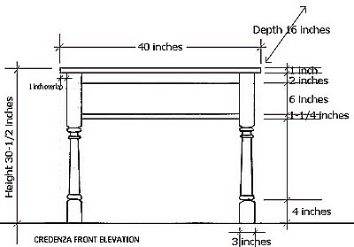

Plan Elevation

Cut List

Final Cut List
Description of Part | Quantity Needed | Species | Length | Width | Thickness | Bdft  (LxWxT/144)

Lumber Yard Cut List
Thickness 4/4, 5/4, 6/4, 8/4, 10/4 | Bdft | Approx. Length  8’ 10’ 12’ | Price per Bdft | Cost

Wood Selection
Introduction to lumber and how to select it

Wood and It’s Properties
- Heartwood / Sap
- Movement
- Density
- Pores
- Drying lumber and Its Consequences
  - Air Dried
  - Kiln Dried
  - Moisture Content - measuring and consequences

How Wood is Cut: Quarter Sawn, Face Sawn, Rift Sawn, Veneers
Sawmills have several different ways of cutting timber into boards. Each sawing methods produces a different look and durability and comes at different prices. The three traditional types of milled wood boarding are plain sawn, quarter sawn and rift sawn lumber.

Plain Sawn Lumber
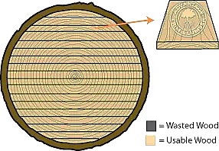
In plain sawing, a sawmill cuts timber into long strips along its length, pulling off boards parallel to one another, like playing cards being separated from a deck.
Plain sawing creates the least waste of any sawing method, is the least expensive and most common method of sawing wood boarding.
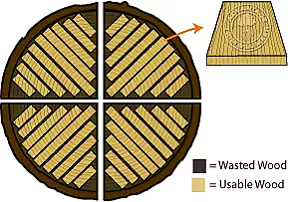
Because each board comes from a distinct “slice” of the tree, each piece of plain sawn lumber will have more variations than a board made from lumber cut by other methods. I extremes of humidity and temperature, these variations make plain sawn lumber more susceptible to expansion and contraction than quarter sawn or rift sawn lumber, and more liable to crack or squeak.

Quarter Sawn Lumber
A “quarter sawn” log is first cut into four “quarters”. Each quarter is then cut into boards through a series of cuts, which are perpendicular to the tree’s rings. The result is a series of boards, each containing a similar slice of the tree radius. Because quarter sawing produces less board feet than plain sawing, quarter sawn lumber is more expensive. However, quarter sawn boards are more consistent than plain sawn boards. This makes them more resistant to shrinkage and expansion in humidity and temperature, and valuable to woodworkers and furniture makers. You can visually recognize quarter sawn wood by its wavy grain patterns.

Rift Sawn Lumber
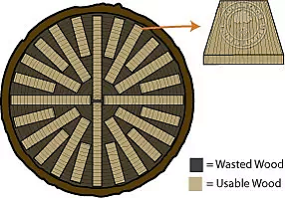
Each rift sawn board is cut from the center of the log, outwards. Rift sawing is similar to quarter sawing except that each rift san cut is make at a slightly different angle. While many wedge – shaped scraps are made, this method also results in boards with similar grain patterns; such boards have great uniformity and stability, even in extremes of temperature and humidity.

- Wood grades and terminology F&S, 2A – 4A, Musical grade
- What are generally available woods locally?
  - Domestic – Cherry, Maple, Walnut-Steamed, Poplar
  - Local Salvages e.g. Heart or Pine (Check out viablelumber.com)
- Issues to think about: Nails and Terminates

How to Calculate How Much Wood You Will Need
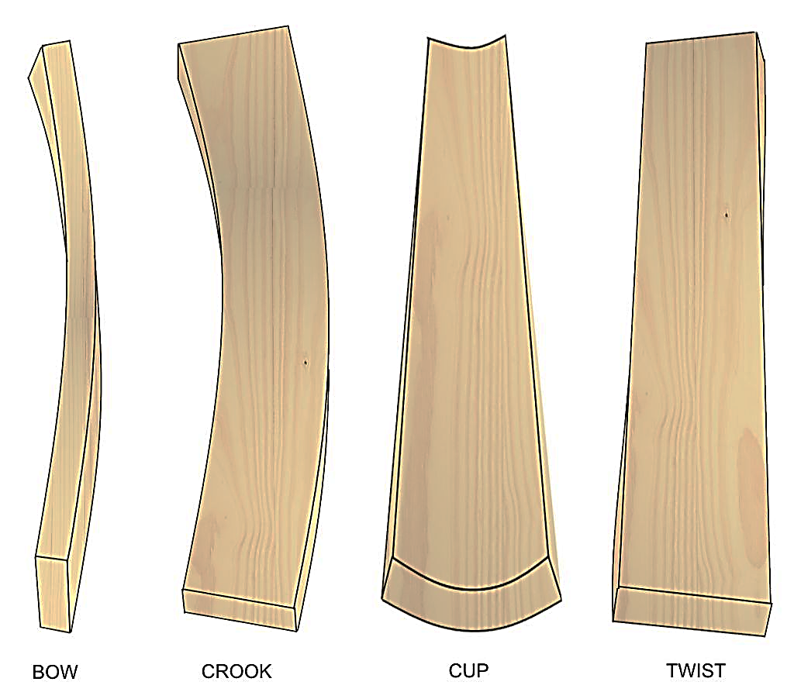
- Using cut lists (www.cutlistplus.com)
- Calculating board feet (LxWxT/144)
- Rough/Nominal

What to Look For When Buying Wood
- Bows, Twists, Cups, Crooks
- Character – Cracks, Knots
- Splits, Wind Check

Places to Buy Wood
Intercity Lumber
5301 Causeway boulevard
Tampa, FL 33619
http://www.intercitylumber.com

Craftsman Supply
1605 North 23rd Street
Tampa, FL 33605

813 988 4677
http://craftsmensupply.com

Hardwood Lumber of Lakeland
4316 Wallace Rd
Lakeland, FL 33812
(863) 646-8681

Woodcraft
2864 Roosevelt Blvd
Clearwater, Fl 33760
www.woodcraft.com

Rome Lumber
5810 North Rome Avenue
Tampa, Fl 33603

Advantage Lumber, Sarasota
Viable Lumber, St. Petersburg
Bushnell Lumber
Weiss Lumber, clearwater
A few examples of Online Sources:
- www.hearnehardwoods.com
- www.westpennhardwoods.com
- www.pinecreekwood.com
Shop Rule: No exotics/ oily woods, no pine, no salvaged woods unless you purchase a set of blades for the jointer and planer ($105)
Note: Once you have purchased your wood, do not leave it in your car aka “The Easy Bake Oven”. Put it in an A/C environment or drop it off at the shop.

Mortise and Tenon Joints

A mortise and tenon joint is nothing more than a square peg in a square hole.
Anatomy of Parts
The specific name of the mortise/tenon piece depends upon its function and orientation.
The mortise piece is usually the upright member, such as a stile, leg, or post. The tenon piece is usually horizontal, such as a rail, an apron, a stretcher, or a shelf. 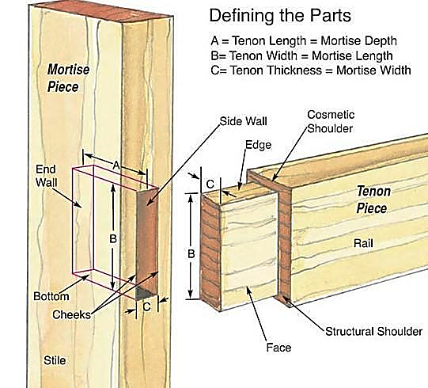
Dimensioning the Parts
- A = Tenon length = Mortise depth
- B = Tenon width = Mortise length
  - Make the tenon width to exact fit. If it’s too narrow, the tenon may float and position the rail in the wrong place. For the same reason, don’t crush the edges of the tenon during assembly thinking you are making the joint tight.
- C = Tenon thickness = Mortise width

Finishing
(Extracted from the article: Selecting a Wood Finish by Jeff Jewitt)
Finishing is one of the biggest bugaboos for many woodworkers. Though they remain undaunted by complex joinery or intricate and precise machining, scores of woodworkers still cringe at the thought of applying a finish to their work. "What's the best finish for my project?" is a question I often hear. Being able to answer that question confidently and comfortably is an important hurdle to overcome.
Finishing products can be grouped into manageable categories, based on general working qualities and the degrees of protection they offer: waxes, oils, varnishes, shellacs, lacquers and water-based finishes. Different finishes offer varying degrees of protection, durability, ease of application, repairability and aesthetics. Unfortunately, no single finish excels in all these categories -- a finish that excels in one may fail in another -- so in choosing a finish you must accept trade-offs.
As a professional refinisher, I routinely ask my customers a series of questions to determine the best finish for their furniture. I've modified my standard questions for this article and added a few as a Checklist for woodworkers trying to decide which finish to use on their own projects. Answers to these questions will point you toward the right finish to use on a given project, based on how well you need to protect the surface, how well the finish will hold up, how easy it is to apply it and how you want it to look.

Questions To Ask About Finishes
- How will the item be used? Will it be subjected to a lot of moisture, solvents, food, scraps, and dents?
- What is your skill level and how big is your work area? Does it stay clean, and is it heated and dry?
- What do you want the wood to look like? Do you want an “in the wood” natural look or a thicker film finish that accentuates depth?
- Will you be filling the pores to attain a highly polished finish?
- Will you be rubbing out the finish to achieve a particular sheen?
- Do you want the finish to alter the color of the wood? Is yellowing an issue? Do you want minimal color changes as the wood ages?
- Safety and health: Are you sensitive to some solvents or concerned about flammability or the environmental impact of certain finishes?
- Toxicity of the finish: Will it be used near areas of food preparation?

Available Finishes
All wood finishes can be classified as one of two distinctly different properties, based on how they dry, or cure.
- Evaporative finishes - such as lacquer, shellas and many water-based finishes - dry to a hard film as the solvents evaporates. (Water is nat a solvent used to thin them, long after they’ve dried, so they tend to be less durable than reactive finishes.
- Reactive finishes - such as linseed or tung oil, catalyzed lacquers and varnishes - also contains solvents that evaporate, but they cure by reacting with either air outside the can or a chemical places in the can before application. These chemical change as they cure, and after that they will not dissolve in the solvent originally used to cure the. /except for oils, reactive finishes tend to hold up better to heat and chemicals.

Waxes
I don't consider wax an appropriate finish in and of itself. I use paste wax (carnauba mostly, sometimes beeswax) to polish furniture but only over other finishes, such as lacquer or shellac.

True Oils
Linseed oil and Tung oil, the drying oils most often used in finishing, are readily available and relatively inexpensive. These finishes are called true oils to distinguish them from other products hyped as oil finishes and to separate them from naturally non drying or semi drying oils used in finishes, such as soybean oil. These true oils change from a liquid to a solid through polymerization, a process that strengthens the cured finish.
- Linseed oil is available in several forms. Unrefined, it's called raw linseed oil, which is rarely used on wood because it dries so slowly. Finishers long ago discovered that by boiling the oil, the resulting product was thicker and dried more quickly. Even though linseed oil that has been boiled is still available -- it's called heat-treated or polymerized oil -- most of the boiled linseed oil sold these days is raw oil that has been mixed with chemical additives to speed up the drying time. For wood finishing, you should use only boiled linseed oil.
- Tung oil is derived from the nuts of trees that are native to Asia but have been cultivated in other parts of the world. Tung oil is available in a pure, unrefined form and in a heat-treated or polymerized form. The heat-treating process makes the oil a bit more durable and speeds up the drying time. It also minimizes a tendency of Tung oil to "frost" (dry to a whitish, matte appearance). Tung oil is paler in color and has better moisture resistance than linseed oil.
- Both linseed and Tung oils are penetrating finishes, which means they penetrate the fibers of the wood and harden. These are the easiest finishes to apply: Wipe them on, allow them to penetrate the surface of the wood and wipe off the excess with a rag. These oils are usually not built up with enough coats to form a surface film, like that of varnish or lacquer, because the film is too soft.

Varnishes
Varnish is made of tough and durable synthetic resins that have been modified with drying oils. Labels on cans of varnish will list resins such as alkyd, phenolic and urethane, and the oils used are Tung and linseed, as well as other semi drying oils such as soybean and safflower. Varnish cures by the same process as true oils -- polymerization -- but the resins make this finish more durable than oil. In fact, oil-based varnish is the most durable finish that can be easily applied by the average woodworker. Varnish surpasses most other finishes in its resistance to water, heat, solvents and other chemicals.
Varnishes that contain a high percentage of oil are called long-oil varnishes. These include marine, spar or exterior varnishes and some interior varnishes for sale on the retail market. Long oil varnishes are more elastic and softer than medium- and short-oil varnishes that contain a lower percentage of oil. Medium-oil varnishes comprise most interior varnishes on the market. Short-oil varnishes (also known as heat-set varnishes and baking enamels) require extremely high temperatures to dry, so they're used only in industrial applications.
The type of resin used in the varnish determines the characteristics of the finish.
- Alkyd varnish is the standard all-purpose interior variety with decent protective qualities.
- Phenolic varnish, usually made with Tung oil, is predominantly for exterior use.
- Urethane varnish, also called polyurethane, offers a better resistance to heat, solvents and abrasions than any other varnish.
Varnish is typically applied with a brush, although a highly thinned and gelled version, called wiping varnish, can be applied with a rag.

Oil and Varnish Blends
These mixtures, mostly oil with some varnish added, offer some of the best attributes of both ingredients: the easy application of true oils and the protective qualities of varnish. (Watco-brand Danish oil, teak oil and several other finishes fall into this category.) It's difficult to ascribe accurate protective qualities to these products because manufacturers don't usually disclose the ratio of oil to varnish. Oil and varnish blends will dry a bit harder than true oils, and the finishes will build quicker with fewer applications.

Shellac
While most people think of shellac as a liquid finish found at a paint store, in its pure form it's a natural resin secreted from a bug that feeds on trees, mostly in India and Thailand. The secretions, in the form of cocoons, are gathered and eventually refined into dry flakes, which are then dissolved in denatured (ethyl) alcohol to make the shellac solution that winds up in cans at the store.
Shellac is available in several varieties. You can buy it premixed, or you can buy it in flake form and mix it yourself with denatured alcohol. The premixed variety is available in orange (amber) and clear, which is shellac that's been bleached. With the flakes, shellac is available in a wider variety of colors and wax contents than with the premixed version (which contains wax). The wax in shellac decreases the finish's resistance to water and prevents some finishes from bonding to it.

Lacquers
Most professionals still regard lacquer as the best all-around finish for wood because it dries fast, imparts an incredible depth and richness to the wood, exhibits moderate to excellent durability (depending on the type used) and rubs out well. There are several different types of lacquer, and they exhibit different performance characteristics.
- Nitrocellulose lacquer is the most common. If the label on the can says lacquer, it's most likely nitrocellulose, which is made from an alkyd and nitrocellulose resin dissolved and then mixed with solvents that evaporate quickly. This type of lacquer has moderate water resistance, but it's sensitive to heat and certain solvents. The biggest drawback is the finish's tendency to yellow as it ages, which shows clearly on light-colored woods.
- Acrylic-modified lacquer is made from a mixture of a non yellowing cellulose resin (called cellulose acetate butyrate, or CAB) and acrylic. This lacquer possesses the same general properties of nitrocellulose lacquer, except it is absolutely water-white, meaning it will not show as an amber color when applied over light-colored woods. Also, the finish won't turn yellow over time.
- Catalyzed lacquer bridges the gap between the application traits of nitrocellulose lacquer and the durability of varnish. Catalyzed lacquer is a complex finish composed of urea formaldehyde or urea melamine and an alkyd that has some nitrocellulose resin added to make it handle like normal lacquer. The addition of an acid catalyst initiates a chemical reaction that forms a very tough, durable finish. Catalyzed lacquer comes in two versions: pre catalyzed and post-catalyzed. Pre Catalyzed lacquer has the components premixed, either by the manufacturer or at the store when you buy it; post-catalyzed lacquer is a two-part system that you must mix in your shop, following precise ratios. Once the catalyst has been added, these lacquers have a short pot life (the time in which they can be used).

